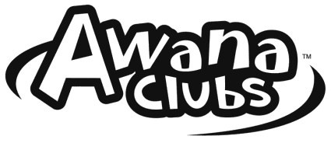
Puggles
2022–2023 Cubbies
FBC Westlake AWANA CLUBS Registration Form ^{Sparks}
T&T

$30 New Club or $20 Same club Registration Fee/One form per Child
Please Print
Child’s Name: ___________________________________ Gender: ______________

Birthday: __________________ Age: __________ Grade: ______________
Month Day Year
Mailing Address: __________________________________________________________
Street City/State Zip
Parent/Guardian Name: _____________________________________________________

Phone Numbers: __________________________________________________________
Cell (texting is the primary form of communication) Other
Email Address: ___________________________________________________________

Church you attend: ________________________________________________________

Emergency Contact Name: ___________________________ Phone: ________________

First Baptist Church Awana Club Activity Permit Westlake, LA
TO WHOM IT MAY CONCERN:
As a parent &/or guardian, I do herewith authorize treatment under the direction of any licensed physician of the following minor ______________________________ in the event of a medical emergency which, in the opinion of the attending physician, may endanger his or her life, cause disfigurement, physical impairment, or undue discomfort if delayed. This authority is granted only after reasonable effort has been made to reach me by phone at the number listed above. The undersigned assumes the responsibility for any costs connected with such treatment and hereby releases First Baptist Church Westlake from any liability therefore. Date when release is intended: September 2022 through April 2023 This release form is completed and signed of my own free will with the sole purpose of authorizing medical treatment under emergency circumstances in my absence.
SPECIFIC MEDICAL ALLERGIES, CHRONIC ILLNESSES, OR OTHER CONDITIONS:
_______________________________________________________________________________

Family Physician: _____________________________Phone: ________________________

Signature of Parent or Guardian: _______________________________ Date: ___________
-------------------------------------------------------------------------------------------------------------------------------------------------
Please let us know your preferences regarding our use of photos of your child.

_____YES, I grant First Baptist Church of Westlake permission to use photos of my child on the church website, on the Awana group church Facebook page, in the church newsletter or in other promotional materials.
____NO, I do NOT want my child’s photo to be used on the church website, on the church Facebook page, in the newsletter or in other promotional material.

